**Boat Wash App**

**Business Requirements Document**

**Ver 1.0**



|  |  |  |  |
| --- | --- | --- | --- |
|  | Prepared By / Last Updated By | Reviewed by | Approved By |
| Name | Ahron |  | ATPL |
| Role | Project Manager |  |  |
| Signature |  |  |  |
| Date | March 24th , 2022 |  |  |

Table of Contents

1.0 Introduction 3

1.1 Purpose of this document 3

1.2 Project Overview 3

1.3 Scope 3

1.3.1 In Scope 3

1.3.2 Out of Scope 4

1.4 Intended Audience 4

1.5 Constraints, Assumptions, and Dependencies 4

2.0 Organization Architecture 5

2.1 Boat wash application team 5

2.2 Augurs Technology Pvt. Ltd. 6

3.0 Business Process Analysis 6

3.1 Current Scenario 6

3.2 Workflow 6

3.3 Admin Panel 14

3.4 Detailed Business requirements 14

4.0 Admin panel detailed Business requirement 17

5.0 Technical specifications 19

6.0 Development timelines/WBS and milestones 19

7.0 References 20

8.0 Change Log 20

# Introduction

## Purpose of this document

This document is aimed at:

* Providing the necessary inputs to the detailed requirements gathering phase and further on for the SDLC processes.
* This document also serves to establish the traceability between the Business Objectives and the requirements identified in the proposed solution and how they satisfy the stated objectives.
* Provide expectation traceability in terms of the requirements and the user expectation
* Serves as a formal template for documenting the Business Requirements which also includes statutory and regulatory requirements.

## Project Overview

To develop an app named – “Boat Wash App” which will be compatible on both android and Ios devices. The app will helpful for the users to book and schedule their time for washing their boats to the nearest service boat wash center.

## Scope

### In Scope

1. Splash screen
2. Next screen – “Is my Boat washable” Text buttons at the bottom –Sailboat or Power boat
3. Next – choosing Sailboat (Description) or choosing Powerboat (Description)
4. Welcome screen (Video on the welcome screen)
5. Sign up /login page
6. Home screen
7. Nearest boat location on the map to choose by the users
8. Product page
9. Check out Page
10. After the payment QR code will be generated and shown on the app
11. User will reach at the service center for washing their boats show the QR code which contains the information of the date, time for the servicing of the boat
12. Confirmation screen “That your boat is wash now”
13. Inboard engines

### Out of Scope

* Any additional task which is not included in this scope document
* 3rd party tools integrations or functionality which is not discussed or captured in this document.
* Any unidentified dependent development activity, get identified during the development phase

## Intended Audience

* Boat wash management team
* Graphic /web UI designer
* Development team
* Augurs Team - Project management group, Delivery Assurance Group & QA group

## Constraints, Assumptions, and Dependencies

Once identified, these assumptions and constraints shape a project in specific, but diverging ways – assumptions bring possibilities, whereas constraints bring limits.

At a minimum, as the project begins, assumptions and constraints must be defined for one or more of the following elements:

* Key project member’s availability
* Key project member’s performance
* Key project member’s skills
* Internal process lead time
* Vendor delivery times
* Vendor performance issues
* Accuracy of the project schedule dates

Project limitations typically fall into several categories.

Our project’s drivers and supporters may have preset expectations or requirements in one or more of the following categories:

**Results:** The products and effects of your project. For example, the new product must cost no more than $300 per item to manufacture, or the new book must be fewer than 384 pages in length.

**Time frames:** there may have a few tasks where the planned timeline may differ from the actual timeline due to the complexity of the hidden scope.

**Resources:** The type, amount, and availability of resources to perform your project work. Resources can include people, funds, equipment, raw materials, facilities, information, and so on.

**Assumptions:**

* The client will provide all content and timely and approvals
* Assuming the details shared by the client are in the scope of development.

**Constraints:**

* Perfectly execution of the Boat wash app infrastructure
* Quality of the features shown on the Boat wash app

**Dependencies:**

* Discussions with the client to understand the core business activities to convert to business logic and its requirements

# Organization Architecture

## Boat wash application team

*Details to be provided by the client

|  |  |  |  |
| --- | --- | --- | --- |
| Name & Position | Primary Responsibilities  (relative to project) | Module | Primary Responsibilities  (relative to application business process) |
|  |  |  |  |
|  |  |  |  |
|  |  |  |  |

## 

## Augurs Technology Pvt. Ltd.

|  |  |  |
| --- | --- | --- |
| **Name & Position** | **Primary Responsibilities (relative to project)** | **Primary Responsibilities**  **(relative to application business process)** |
| Ana(Business Analyst) | Overall project management both from  Client-end and development team. | Managing complete project. Responsible for solving any concern of the client, team. |
| Peter (Project Manager) | Overall Project  management and its closure | Managing the whole project from the scratch |
| Development team | Responsible for the development of the  Complete Boat Wash application | Collect and understand the initial requirement of the application and work accordingly. |

# Business Process Analysis

## Current Scenario

To develop an app named – “Boat Wash”. The application will be helpful for the users who has their boats and want to wash them at the nearest service wash center. The application will be helpful for the users in various aspects in terms of the Quality of the washing and payment prospect and on time delivery of the boat after washing.

## Workflow

Once the user will open the application he/she will be able to navigate the app below is the flow that will be implemented within the application

* **Splash Screen:** Once the user will open the applications, it is the very first screen which will be shown to the user in the application. Below is the figure representing the splash screen of the app

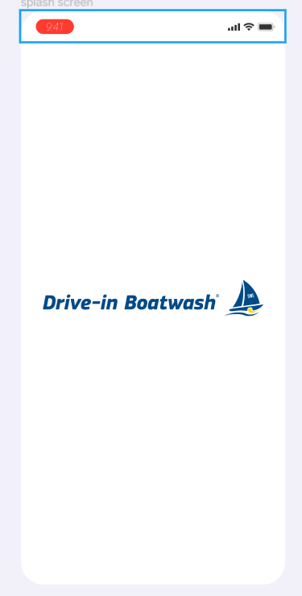

* **Landing page:** After the splash screen next screen would be the landing page of the app , which will show you within the app , below is figure representing the Landing page of the app

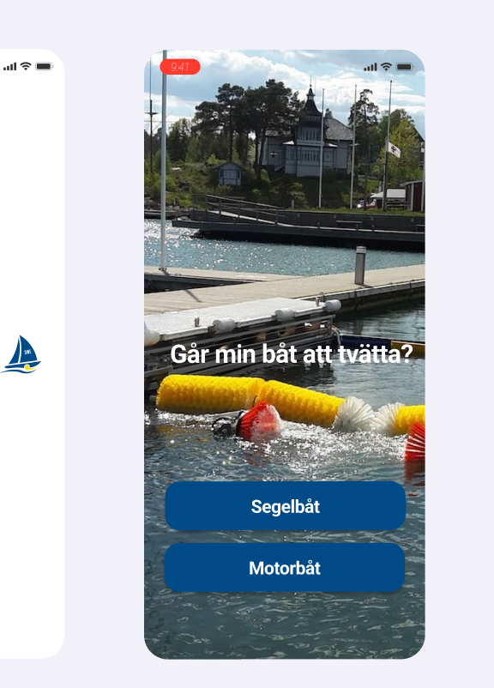

* **Can I wash my boat:** After the landing page of the app user will redirect towards the “Can I wash my boat” page by after clicking on the Sailboat and power boat page, the description will also be present which will be added by the admin at the blackened. below is the images which will be shown for sailboat and power boat with description

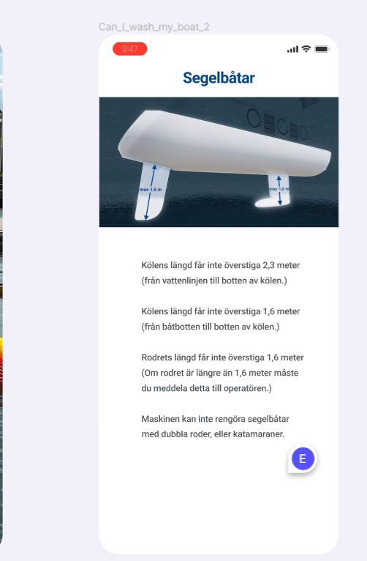 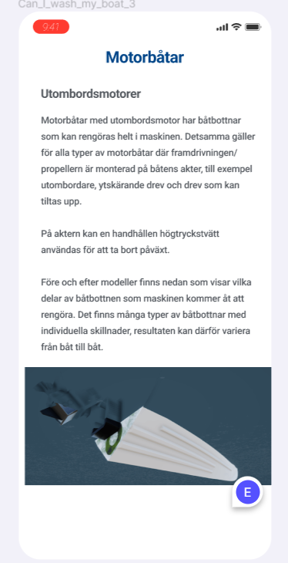

* **Welcome screen:** After that user will be redirect towards the welcome screen within the app where one video will be flashed and there will be two options present one for creating your user account and other for login if already registered. **Below is the figure represents the welcome screen**

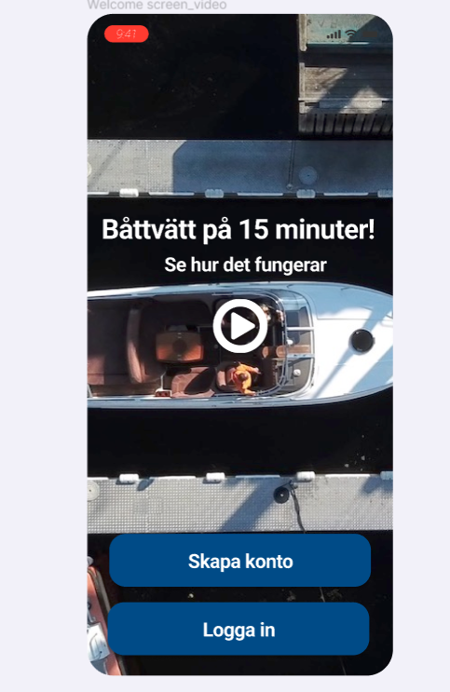

* **User registration page (Signup):** Once the user will click on this feature within the application he/she will need to fill his/her details such as
* Name
* Email address
* Password, Below is the screen which will be shown on the user account creations for sign up process

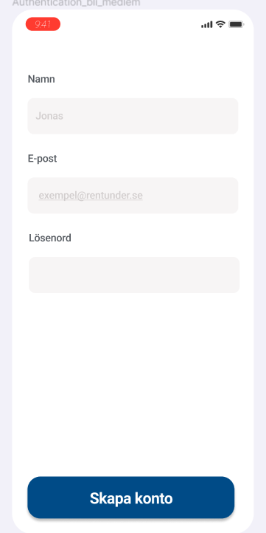

* **Login :** Just need to fill email id and password to login as a user on the application , please refer the image below

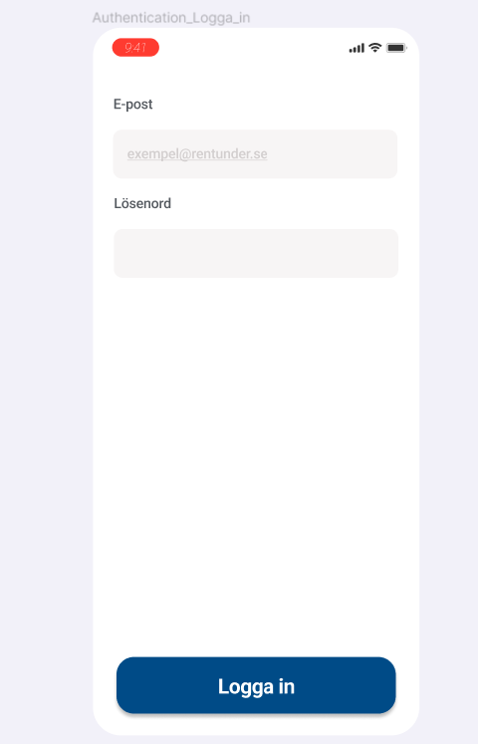

* **Home Screen:** After the successful completion of the login process user will redirect towards the Home screen of the app. which will show the map of the location from which user will be able to see the nearest boat wash centre and the name of the boat wash centre will be listed below to the map. Below is image which represents the Home screen within the app, search bar will also be there to search by using the keywords , the service centres will be listed by the admin at the backend .

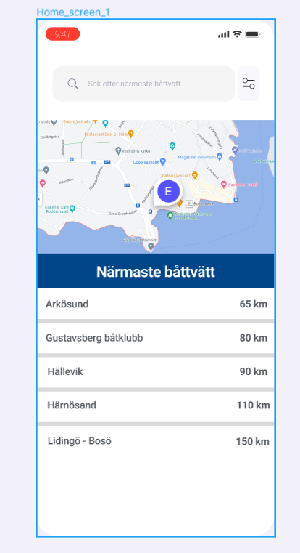

* **Product page :** After choosing the service centre from the list shown on the app user will redirect towards the product page from there he can see the name of the service centre their address price for washing as per the number of months , user can also add and subtract the number of washes by clicking on “+” and “-“ button. And Buy button to proceed for the booking See the below attached image to show the product page

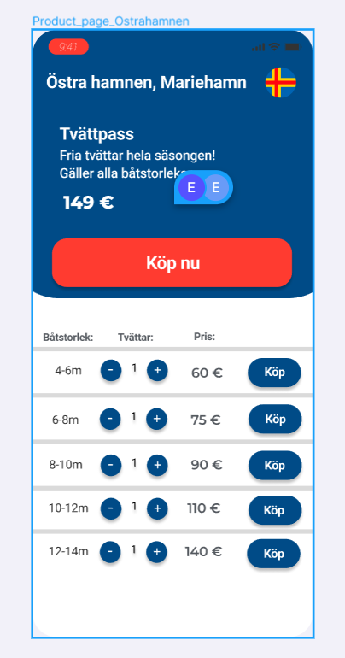

* **Checkout Page:** After clicking on the “Buy” Button for the booking slot for the boat wash user will redirect towards the Checkout page for the payment process.Stripe payment gateway will be used for the merchant transactions , refer the below image for the checkout

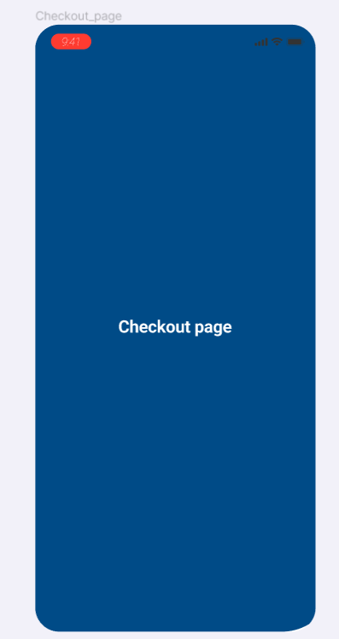

* **Confirmation page:** After the successful wash of your boat to your nearest service centre user will get the confirmation message that his/her boat is successfully washed , user has to click on the button below which is for the confirmation that your boat is washed , It will also shows the users that your boat can be washed or it cannot be washed with description at the bottom below is the image showing the reference

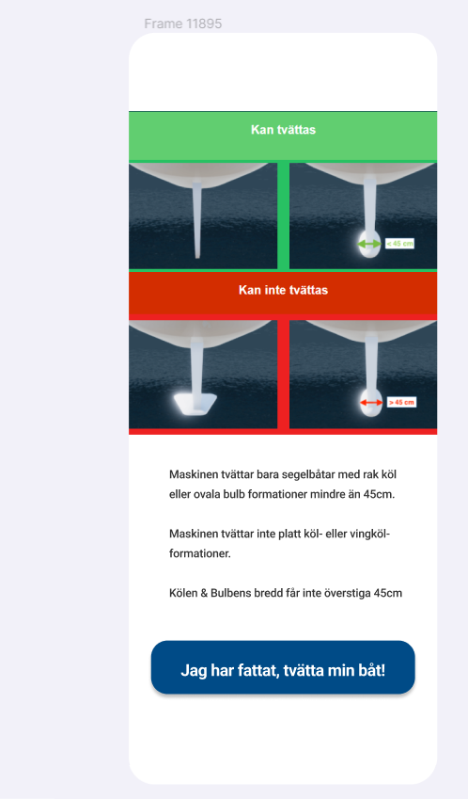 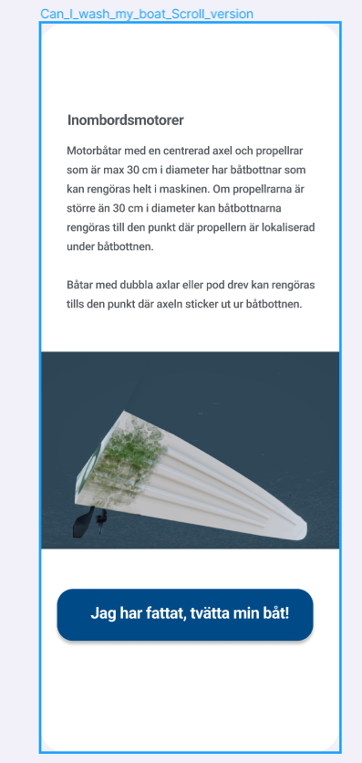

## Admin Panel

As far as app will be developed we need to develop its admin panel for the managing the application from the backend, below are the required features will be present at the admin panel

* Admin dashboard
* User Management
* Content management
* Transaction Management

## Detailed Business requirements

| Req. No | **Requirement ID** | Business Requirement | Req. Type * | Priority ** | Originator *** | BR Traced to Business Requirement/ Use case ID |
| --- | --- | --- | --- | --- | --- | --- |
| 1 | BR001 | * **Designing of the App screens (In XML )** * Project set up * Splash Screen * Landing page of the app * Can I wash my boat page * Home screen * Sign up * Login * Product page * Check out page * Confirmation page and Sign off page * Internal testing and fixes | UI | 1 |  |  |
| 2 | BR002 | * **Development & Functionality (Android & Ios)** * Landing page development * Sailboat or Power boat button selection * Description of Sailboat and Powerboat screen * Can I wash my boat screen development * Testing and fixes | F | 1 |  |  |
| 3 | BR003 | * **Development & Functionality (Android & Ios)** * Sign up /login button functionality to choose any one of them on the Welcome Screen * Sign up page API creation and its implementation as per the required fields * Login page API creation and its implementations as per the required given fields * Internal testing and fixes | F | 1 |  |  |
| 4 | BR004 | * **Development & Functionality (Android & Ios)** * Home page * Search tab * Filter search based on location * Map view on the home screen to show nearest wash boat centre * List of the wash centre API creation * Internal testing and fixes | F | 1 |  |  |
| 5 | BR005 | * **Development & Functionality (Android & Ios)** * Product page (choose time of boat wash, number of services, Buy CTA button, price for the particular wash centre , description of the boat wash centre) * Checkout page * Stripe payment gateway * Internal testing and fixes | F | 1 |  |  |
| 6 | BR006 | * **Development & Functionality (Android and ios)** * QR code generation after the successful payment process * Confirmation message on the screen whether your boat can be washed or not * After the wash of users boat sign off that your boat is washed * Internal testing and fixes | F | 1 |  |  |

# Admin panel detailed Business requirement

| Req. No | **Requirement ID** | Business Requirement | Req. Type * | Priority ** | Originator *** | BR Traced to Business Requirement/ Use case ID |
| --- | --- | --- | --- | --- | --- | --- |
| 1 | BR001 | * **Admin panel theme set up** * Admin dashboard * Admin user management * Content management * Transaction Management * Internal testing & fixes | UI | 1 |  |  |
| 2 | BR002 | * **User Management development** * User name * Email id * Phone number * Address * Last service date * New service request * Action (Add/edit/delete) * Testing and fixes | F | 1 |  |  |
| 3 | BR003 | * **Content Management development (Sub sections)** * Welcome screen content management (Upload/add/delete) * Landing page content management (Upload/add/delete) * Home screen content management (Upload/add/delete) * Product page content management (Upload/add/delete) * List of the wash centres * API creation and integration with frontend features * Testing and fixes | F | 1 |  |  |
| 4 | BR004 | * **Transaction Management development** * User name * Email id * Phone number * Payment status(Success/failed/pending) * Upgrade plan for the each wash * API creation and its implementation from the frontend features * Testing and fixes | F | 1 |  |  |

# Technical specifications

* Native app

# Development timelines/WBS and milestones

Refer to the below-attached link:

<https://docs.google.com/spreadsheets/d/11is1K_ejsJOolZOpWTKWs6b9bCKgYCgw/edit#gid=1750878895>

# References

Below is the location to get references from client communication

Client communication [(To be added by the person communicating with the client)](D:\\Project.Docs\\2020.11.17.e20.io\\2020.11.20.Shared.With.Client\\ATPL-20201117-e20.io\\Client.Discussions)

# Change Log

|  |  |
| --- | --- |
| Version Number | Changes Made |
| V1.0 | Initial baseline created on March 24th , 2022 |
| V1.1 | |  |  |  |  | | --- | --- | --- | --- | | Section No. | Changed By | Effective Date | Changes Effected | |  |  |  |  | |  |  |  |  | |  |  |  |  | |

# 